July 24-27, 2023
Location: First Baptist Church (across from school)
Time: 6-8 pm

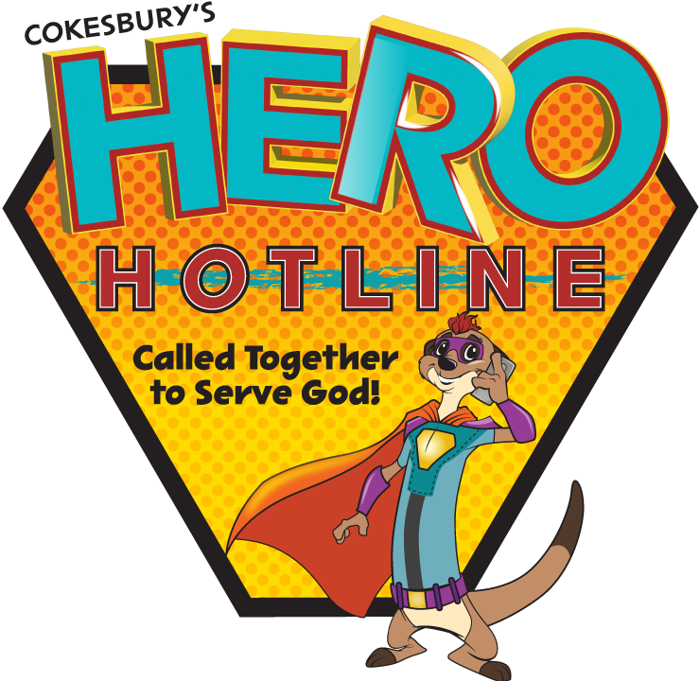
Free to the community from First Baptist, St. Mark’s Episcopal, United Methodist, First Presbyterian and Faith Community Church.

For more information please contact Deb Shultz at 506-2424

